PENETRATION TESTING REPORT
FOOTPRINTING & NETWORK SCANNING PHASES

W2-PM-FINAL | CYBERSECURITY | NETWORKWALKS
Pentester Name | Ng Jian Nian
Program/Batch | B082- Networkwalks Cybersecurity Internship
Date | 17 August 2026 to 24 August 2026
Modules Completed | W2-PM1 (Multiple Kali Tools)  W2-PM5 (Zenmap Scanning)
Client/Target | 1. Networkwalks (secured written permission already)  2. My own local LAN Network
Permission Secured from Client | Yes
Phases Covered | Phase 1: Reconnaissance & Footprinting  Phase 2: Scanning & Network Discovery  Phase 3-5: In Progress

- Liability Disclaimer
This penetration testing report and all associated activities conducted between 17th August 2026, and 24th August 2026, were performed strictly within the authorized scope on systems for which explicit written permission was secured. The materials, findings, and methodologies detailed herein are provided by Networkwalks solely for educational, research, and authorized remediation purposes. Any unauthorized use, reproduction, or execution of these techniques outside the permitted scope is strictly prohibited and violates applicable laws. Neither the authors, the instructors, nor Networkwalks assume any liability or responsibility for misuse or unlawful actions taken using this knowledge; all actions and consequences remain the sole responsibility of the user.

- Introduction
This report presents the findings of a penetration testing engagement conducted by Networkwalks between August 16, 2026, and August 21, 2026. The assessment focused on passive reconnaissance against networkwalks.com alongside active network discovery within a dedicated personal pentesting laboratory. Covering core modules W2-PM1 (Multiple Kali Tools) and W2-PM5 (Zenmap Scanning), this document outlines the tools, methodologies, and technical insights gathered across both target environments.

- Tools Used
The table below lists each tool used in this report and its purpose.
Tool | Purpose
Kali Linux & Windows | Operating systems used for reconnaissance activities
VirtualBox | Penetration testing lab
WHOIS | Find domain registration details (owner, dates, name servers).
whatweb | Fingerprint web technologies (server, CMS, plugins, IP).
nslookup | Resolve the domain name to its IP address using DNS.
curl -I | Read the HTTP response headers of the website.
wafw00f | Detect whether a Web Application Firewall protects the site.
dnsrecon | Enumerate all DNS records (NS, MX, SPF, TXT, SRV).
Zenmap (Nmap GUI) | Scan the local subnet to find live hosts, IPs and MAC addresses.
Windows CMD | Local IP and MAC address identification

- Activities Performed
  - Footprinting & Reconnaissance
I performed footprinting and reconnaissance against the networkwalks.com domain and local lab environment using Kali Linux hosted inside VirtualBox, utilizing six primary reconnaissance tools alongside Zenmap for discovery: WHOIS, WhatWeb, Nslookup, Curl, Wafw00f, DNSRecon, and Zenmap (Nmap GUI). Each tool was used to collect a different type of information about the target assets.
First, I used WHOIS to obtain publicly available domain registration information and identify the domain’s primary name servers. The results provided detailed information regarding the domain ownership, registrar details, and core hosting infrastructure.
I then used WhatWeb to identify technologies powering the website. The scan fingerprinted the underlying web stack, identifying the active web server, CMS components, plugins, and server IP address exposed by the website.
Using Nslookup, I queried DNS servers directly to resolve the domain name to its public IP address. The command successfully mapped the target domain name to its active destination IP address.
I used Curl with the -I option to fetch and inspect the HTTP response headers. This revealed underlying web server software versions, caching configurations, cookies, and exposed web endpoints.
Next, I used Wafw00f to probe the web application for active perimeter defenses. The tool analyzed HTTP responses to detect whether a Web Application Firewall (WAF) was actively inspecting and filtering incoming web traffic.
I used DNSRecon to perform comprehensive DNS record enumeration. The tool systematically extracted complete DNS records, including Name Servers (NS), Mail Exchanges (MX), Sender Policy Frameworks (SPF/TXT), and Service (SRV) records.
Finally, I used Zenmap (Nmap GUI) within the VirtualBox environment to execute local subnet scanning. The scan swept the active network segment to discover live hosts, assigned IP addresses, and physical MAC addresses across the personal pentesting lab.

  - Network Scanning with Zenmap
For the second activity, I used Zenmap to perform network discovery on my local network in VirtualBox. The practical required me to identify my local IP address and subnet, discover live hosts, capture their IP and MAC addresses, and generate a network topology.
I first used the Windows ipconfig command to find my local IP address and subnet. I then entered the subnet into Zenmap and ran a Ping Scan to discover active hosts. Finally, I inspected the host details to extract MAC addresses and viewed the generated topology map.
The example results provided in the practical identified five live hosts:
IP address
- 10.0.0.1
- 10.0.0.2
- 10.0.0.10
- 10.0.0.11
- 10.0.0.16
MAC address
- 52:54:00:12:35:00
- 08:00:27:18:BE:7F
- 08:00:27:D2:2F:BD
- 08:00:27:8A:F2:13
After completing the scan, I opened the Topology section in Zenmap, enabled the legend and saved the network topology in PDF format as required by the practical task

- Risk Analysis / Impact
Based on the information collected during the footprinting and network scanning activities, I identified the following potential risks.
# | Risk / Finding | Evidence / Observation | Potential Impact | Risk Level
1 | Web technology information exposed | WhatWeb identified WordPress and WP Download Manager | Attackers may use exposed technology/version information to identify software requiring further security review | ● Medium
2 | Server IP address identifiable | Nslookup resolved the domain to 192.232.216.135 | Provides information about the network location of the web service | ● Low
3 | HTTP technical information exposed | Curl returned HTTP response headers and exposed /wp-json/ | May assist technology fingerprinting and further enumeration | ● Low
4 | WAF technology identifiable | Wafw00f identified ModSecurity (SpiderLabs) | Reveals information about the web application’s security architecture | ● Low
5 | DNS infrastructure information exposed | DNSRecon identified DNS, mail and service-related records | DNS information can help build a broader infrastructure profile | ● Medium
6 | Multiple live hosts visible on local network | Zenmap identified four live hosts in the example network | Unknown or unauthorized devices may potentially be present on a network | ● Medium
Risk level key: ● Critical ● Medium ● Low

- Recommendations
Based on the findings of this security assessment, the following remediation steps and best practices are recommended:
- Audit Exposed Technical Data: Organizations must routinely audit public-facing assets to monitor what information regarding underlying web frameworks, CMS platforms, and active plugins is accessible to outside parties.

- Maintain Patch Management: Web applications, content management systems, and third-party plugins should be patched regularly and monitored for newly disclosed vulnerabilities.

- Sanitize HTTP Headers: Web server configurations should be sanitized to strip unnecessary version numbers and technical metadata from HTTP response headers.

- Audit DNS Records Periodically: Public DNS zones should be audited regularly to ensure that only essential records, hostnames, and service details remain publicly exposed.

- Maintain and Fine-Tune WAF Rules: Ensure Web Application Firewalls (such as ModSecurity) remain actively managed, properly tuned, and updated to block baseline exploit attempts effectively.

- Conduct Periodic Internal Audits: Organizations should perform scheduled internal network sweeps to maintain visibility over all connected assets and live hosts.

- Analyze Unidentified Assets: Any unauthorized or unrecognized endpoints detected during network discovery scans should be isolated, verified, and investigated promptly.

- Keep Network Records Current: Network topology diagrams, inventory lists, and IP allocation schedules should be continuously documented and kept up to date.

- Ensure Testing Compliance: Reconnaissance, scanning, and security assessments must strictly take place within authorized boundaries and under explicit written permission.

- Conclusion
During the second week of my Cybersecurity & Ethical Hacking internship, I carried out hands-on exercises focused on footprinting, intelligence gathering, and active network scanning.

The footprinting phase involved utilizing six core Kali Linux utilities to evaluate the target domain. This demonstrated how WHOIS reveals domain registration metadata, WhatWeb uncovers the underlying web technology stack, Nslookup determines IP mappings, Curl exposes HTTP response headers, Wafw00f detects perimeter Web Application Firewalls, and DNSRecon extracts comprehensive DNS zone details.

The subsequent network scanning phase relied on Zenmap to analyze local network settings, sweep for live endpoints, document IP and physical MAC addresses, and render a visual topology map of the environment.

These practical tasks highlighted that preliminary information gathering forms the foundation of any security evaluation. Well before launching exploit attempts, an analyst can gain deep visibility into a system's exposure merely by evaluating public records and passive network traffic. Furthermore, the experience emphasized the need for precise technical reporting—effective documentation must detail the methodology used, specific observations made, the security risks introduced, and practical steps to mitigate those threats.

Finally, these exercises reinforced that all scanning and intelligence-gathering efforts must strictly adhere to legal boundaries and written authorization. Every task described in this document was performed purely for educational purposes within a controlled laboratory setting.

- Evidences Collected

Whois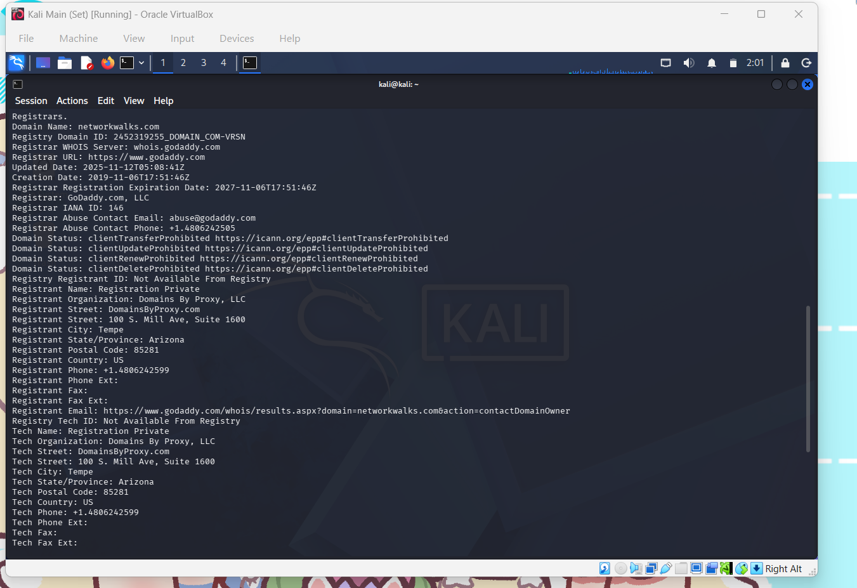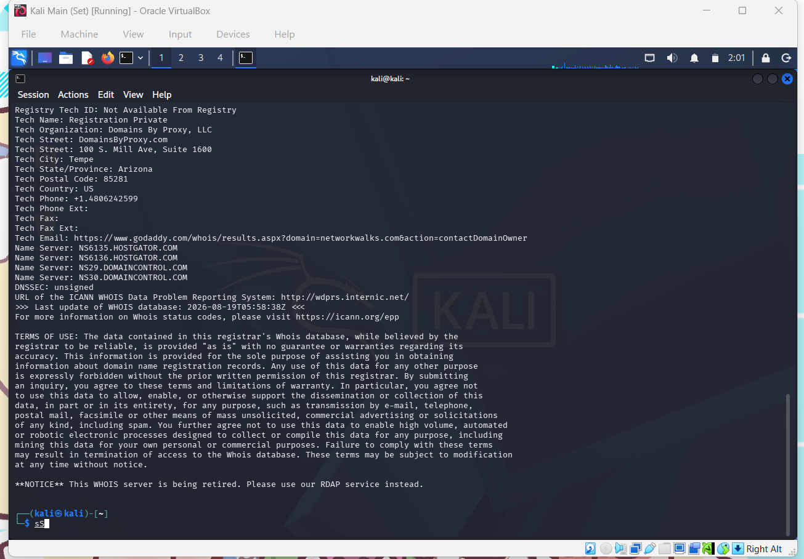
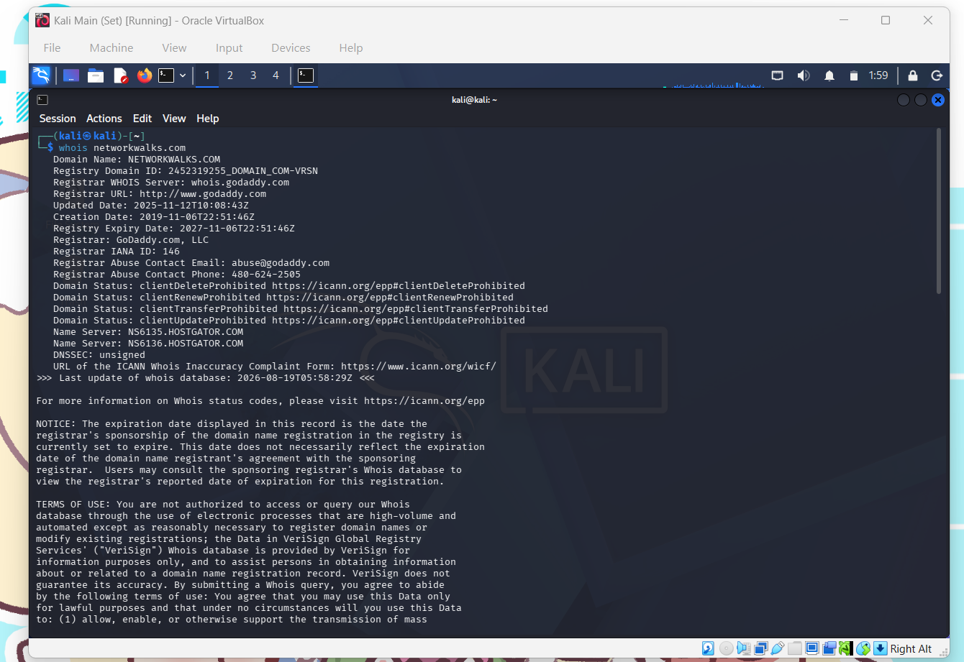
Whatweb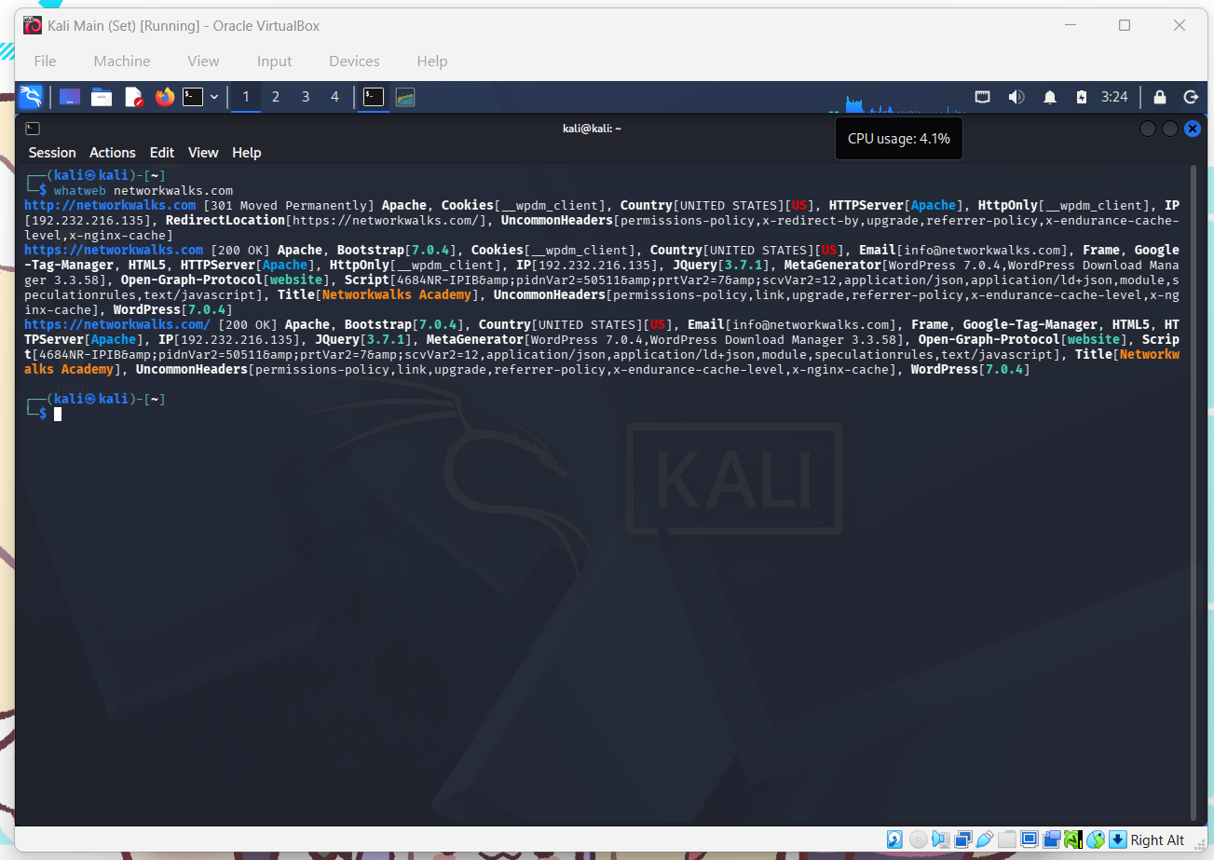

Nslookup
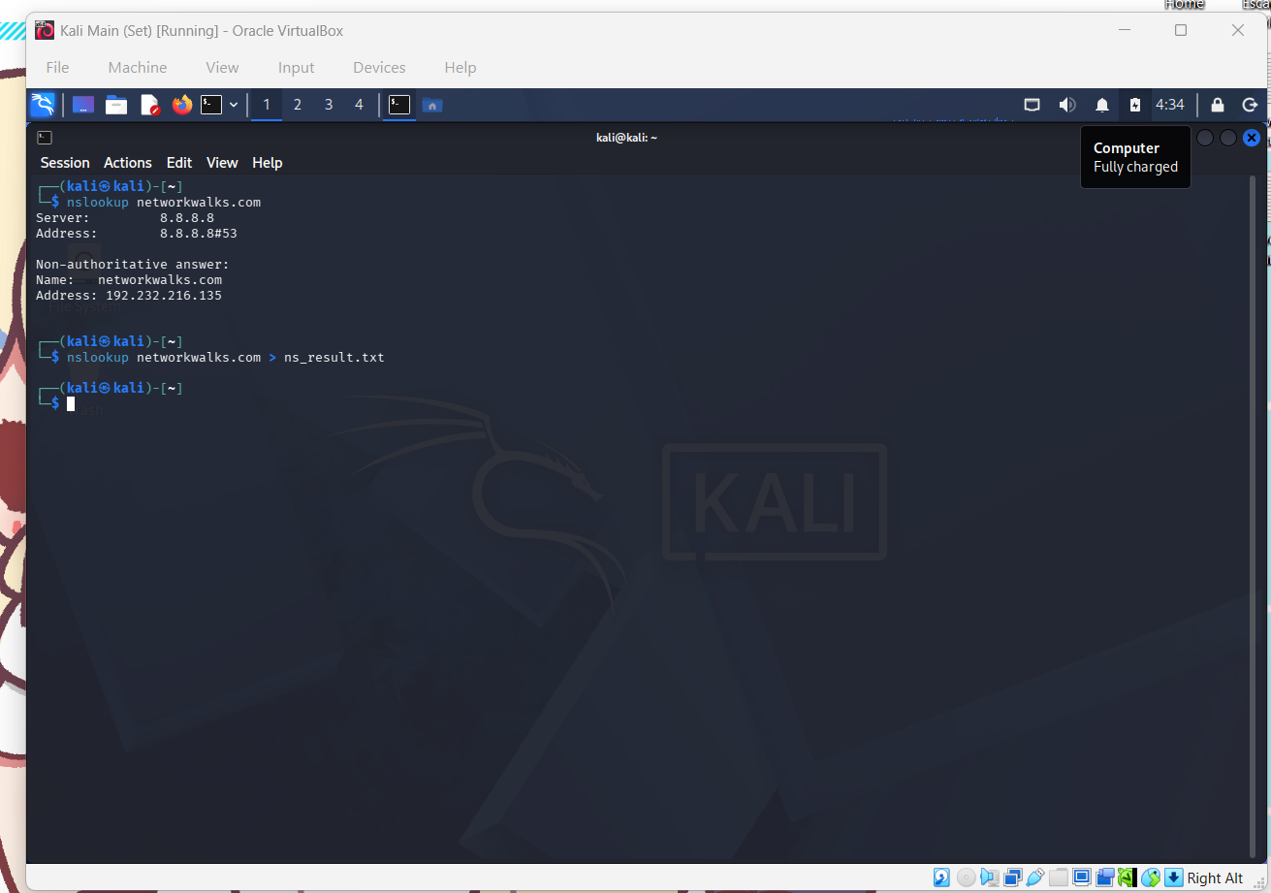
Curl -i
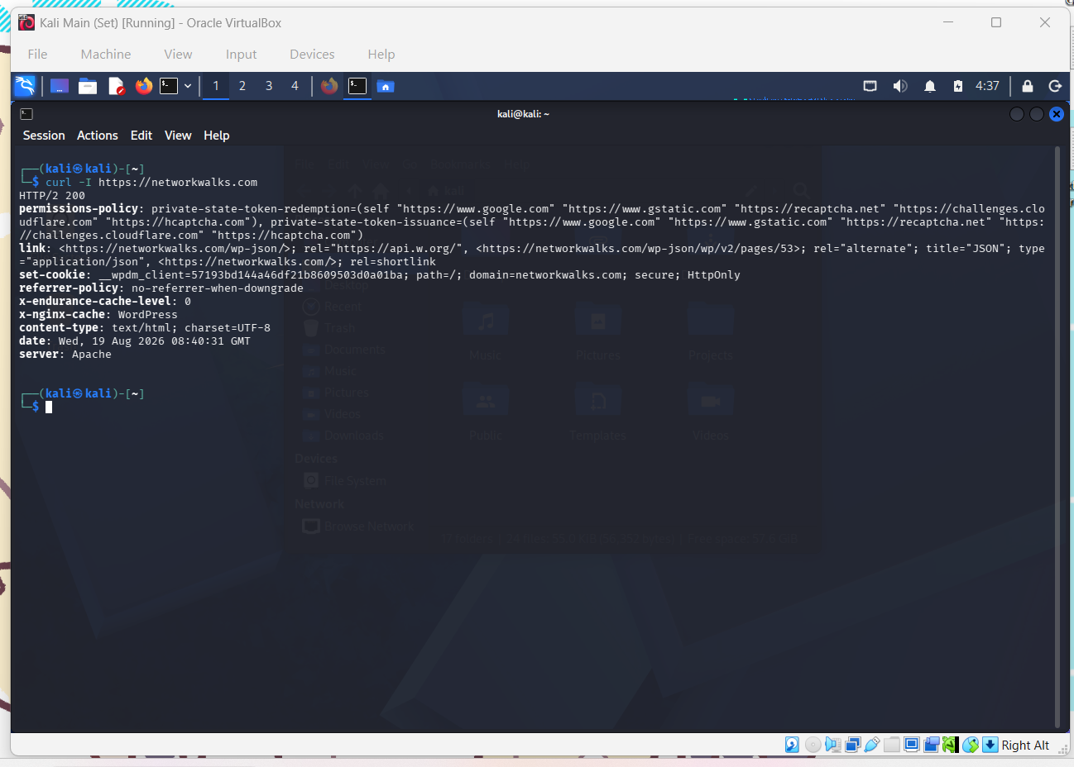

warw00f
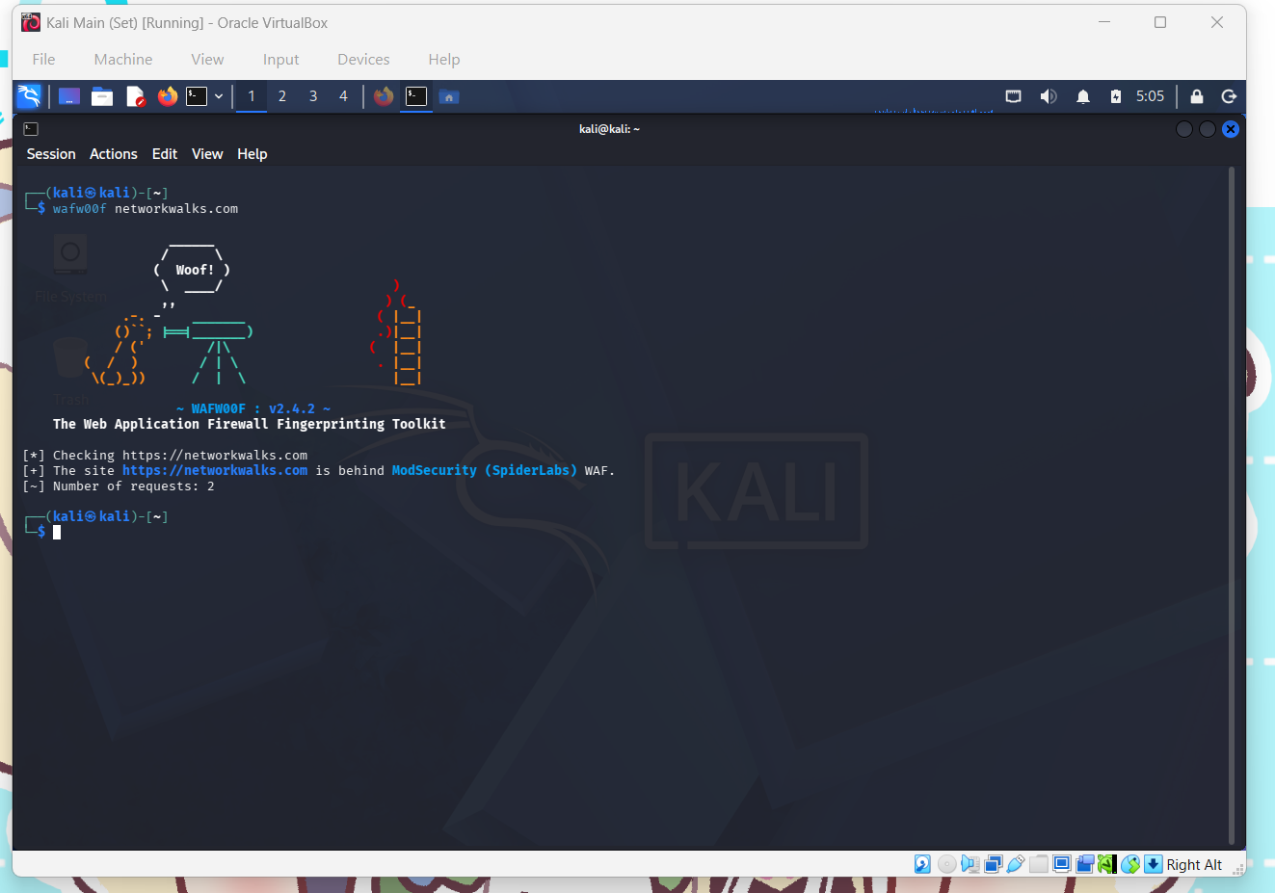

dnsrecon
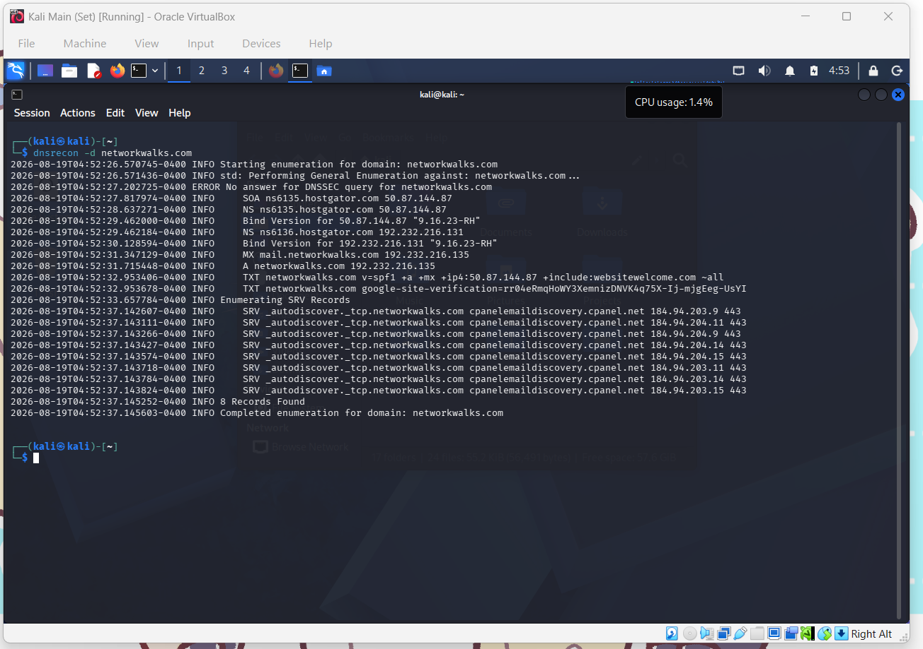

ipconfig
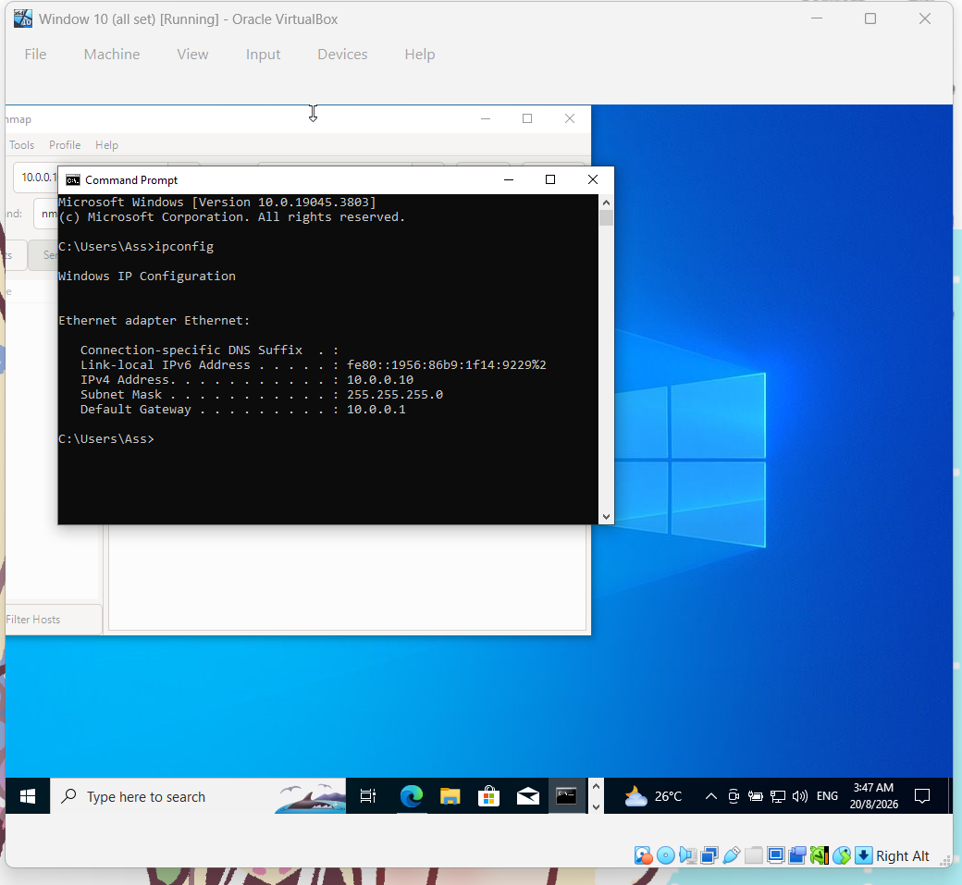

Nmap scan
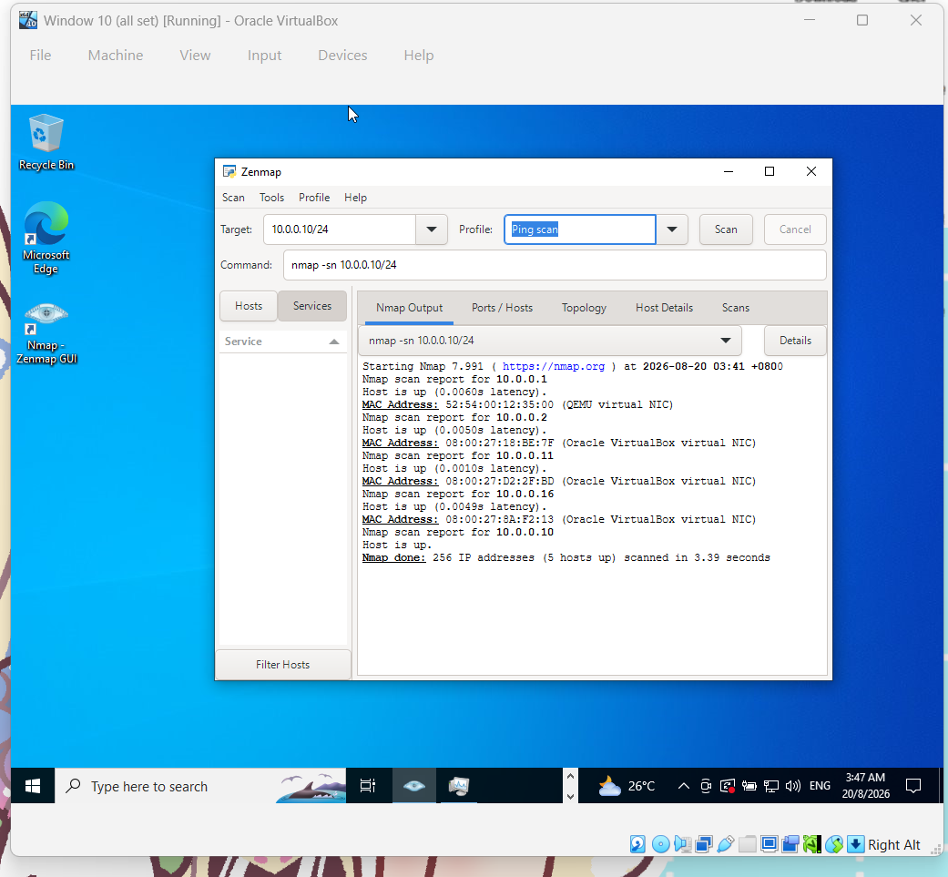

Topology
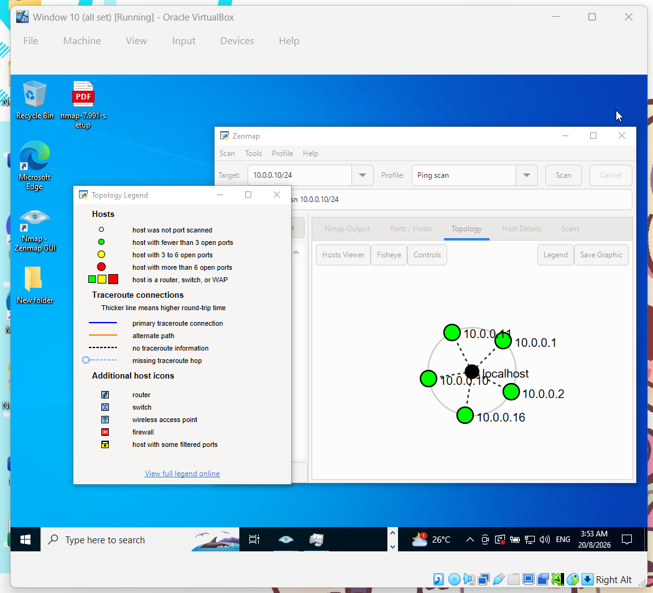

👤 Author
Ng Jian Nian
Cybersecurity Professional B082
LinkedIn: https://www.linkedin.com/in/jian-nian-ng-5083a2387

📌 Project Information
Program Name: Cybersecurity program at Networkwalks | Week: 02 | Repository: GitHub

